DIAGRAM
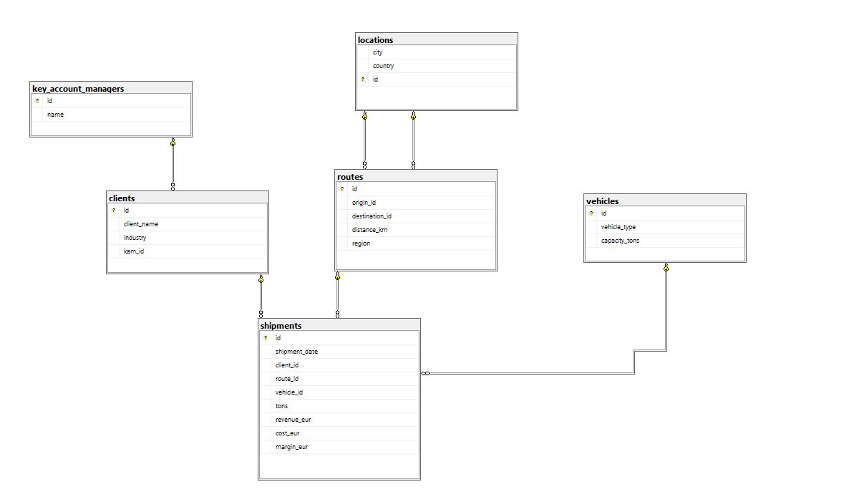

-- 1. How many shipments have been completed in total?
-- 2. What is the total revenue per client?
-- 3. Which clients had more than 100 shipments in 2024?
-- 4. What is the average margin (margin_eur) per route?
-- 5. Which vehicle type is used most frequently?
-- 6. What is the total margin per region within each industry?
-- 7. Who are the top 5 clients by revenue per ton?
-- 8. What is the average revenue per shipment by year and month?
-- 9. Which Key Account Manager (KAM) manages the largest number of clients, and what is the margin per client for each KAM?
-- 10. Which route (origin → destination) has the highest total distance (kilometers)?
-- 11. What is the revenue ranking of clients within each industry?
-- 12. What are the monthly revenue figures and the cumulative revenue (running total)?
-- 13. What is the Year-over-Year (YoY) and Month-over-Month (MoM) revenue growth?
-- 14. What is the profit margin percentage per client, the deviation from the average margin, and each client’s revenue share in total revenue?
-- 15. What is the most profitable route per region (Top 1 per region)?

/* =========================================================
1. Koliko je ukupno pošiljki realizovano?
========================================================= */

-- Izračunati ukupan broj zapisa u tabeli shipments.

SELECT
COUNT(id) AS Number_of_shipments
FROM
shipments;



/* =========================================================
2. Koliki je ukupan prihod (revenue) po klijentu?
========================================================= */

-- Prikazati client_name i SUM(revenue_eur).
-- Potrebno je JOIN-ovati shipments i clients.
-- Grupisati po client_name.

SELECT
client_name,
ROUND(SUM(revenue_eur),2) AS Total_Revenue
FROM
clients
LEFT JOIN
shipments
ON
clients.id = shipments.client_id
GROUP BY
client_name
ORDER BY
Total_Revenue DESC;
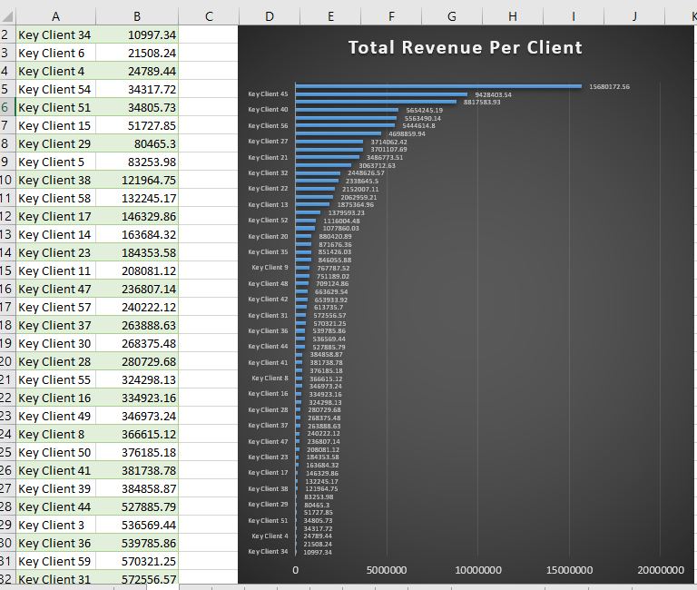

/* =========================================================
3. Koji klijenti su imali više od 100 pošiljki u 2024. godini?
========================================================= */

-- Izračunati COUNT po client_id.
-- Filtrirati koristeći HAVING > 100 i gde je YEAR = 2024.
-- Prikazati client_name i broj pošiljki.

SELECT
client_name,
YEAR(shipments.shipment_date) AS YearOfShimpent,
COUNT(shipments.id) AS TotalShipments
FROM
clients
LEFT JOIN
shipments
ON
clients.id = shipments.client_id
GROUP BY
client_name,
YEAR(shipments.shipment_date)
HAVING
COUNT(shipments.id) > 100 AND
YEAR(shipments.shipment_date) = 2024
ORDER BY
TotalShipments DESC;
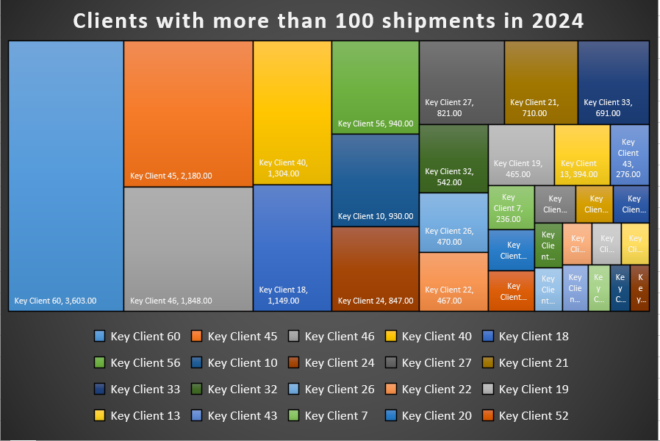
/* =========================================================
4. Koliki je prosečan margin_eur po ruti?
========================================================= */

-- Grupisati po route_id.
-- Izračunati AVG(margin_eur).

SELECT
route_id,
city,
ROUND(AVG(margin_eur),2) AS Average_Margin
FROM
locations
LEFT JOIN
routes
ON
locations.id = routes.destination_id
LEFT JOIN
shipments
ON
routes.id = shipments.route_id
GROUP BY
route_id,
city
ORDER BY
Average_Margin DESC;
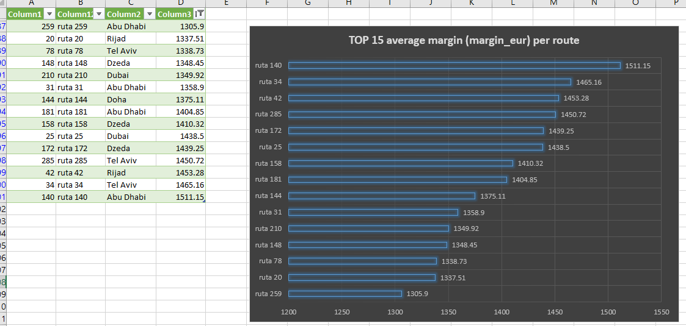

/* =========================================================
5. Koji tip vozila je najčešće korišten?
========================================================= */

-- JOIN shipments i vehicles.
-- COUNT broj pošiljki po vehicle_type.
-- Sortirati opadajuće po broju pošiljki.

SELECT
vehicle_type,
COUNT(shipments.id) AS TotalShipments
FROM
vehicles
LEFT JOIN
shipments
ON
vehicles.id = shipments.vehicle_id
GROUP BY
vehicle_type
ORDER BY
TotalShipments DESC;
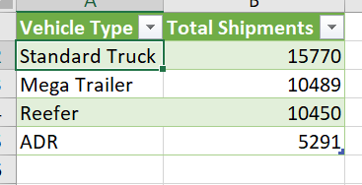
/* =========================================================
6. Kolika je ukupna margina po regionu unutar svake industrije?
========================================================= */

-- JOIN shipments i routes i JOIN shipments i clients .
-- SUM(tons) po region PARTITION BY industry.
-- Grupisati po region.

SELECT
clients.industry,
routes.region,
ROUND(SUM(shipments.margin_eur),2) AS total_margin_eur
FROM
shipments
LEFT JOIN
routes
ON shipments.route_id = routes.id
LEFT JOIN
clients
ON shipments.client_id = clients.id
GROUP BY
clients.industry,
routes.region
ORDER BY
clients.industry,
routes.region DESC;
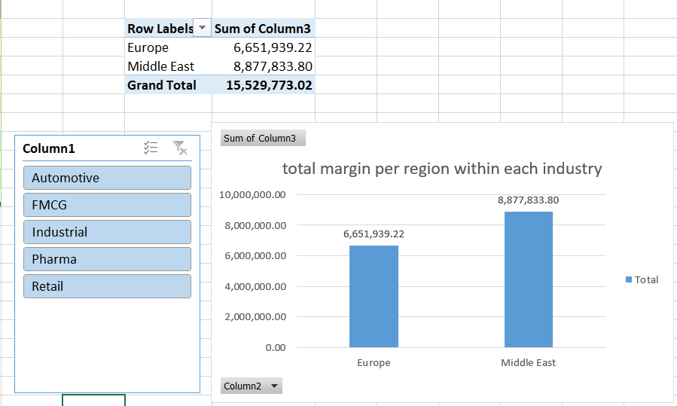

/* =========================================================
7. Koji su top 5 klijenata po prihodu po toni?
========================================================= */

-- SUM(revenue_eur)/SUM(tons) po client_name.
-- Sortirati opadajuće.
-- Koristiti TOP 5.

SELECT TOP 5
client_name,
SUM(revenue_eur)/SUM(tons) AS RevenuePerTone
FROM
shipments
LEFT JOIN
clients
ON
shipments.client_id = clients.id
GROUP BY
client_name
ORDER BY
RevenuePerTone DESC;
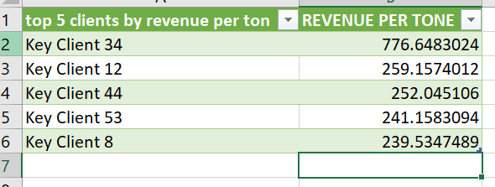

/* =========================================================
8. Koliki je prosječan revenue po pošiljci po godinama i mesecima?
========================================================= */

-- Izračunati AVG(revenue_eur) iz shipments GROUP BY YEAR and MONTH.

SELECT
YEAR(shipments.shipment_date) AS Year,
MONTH(shipments.shipment_date) AS Month,
ROUND(AVG(revenue_eur),2) AS AverageRevenue
FROM
shipments
GROUP BY
YEAR(shipments.shipment_date),
MONTH(shipments.shipment_date)
ORDER BY
Year ASC,
Month ASC;
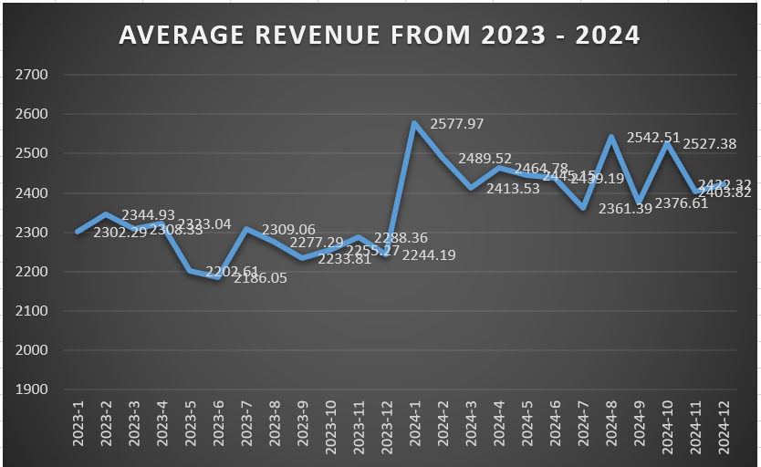

/* =========================================================
9. Koji KAM upravlja najvećim brojem klijenata i koliku marginu po klijentu ima koji?
========================================================= */

-- JOIN clients i key_account_managers.
-- COUNT broj klijenata po KAM-u.
-- Sortirati opadajuće po margini po klijentu.

WITH kam_margin AS (
SELECT
c.kam_id,
ROUND(SUM(s.margin_eur),2) AS total_margin
FROM clients c
LEFT JOIN shipments s
ON c.id = s.client_id
GROUP BY
c.kam_id
),
kam_clients AS (
SELECT
kam_id,
COUNT(*) AS number_of_clients
FROM clients
GROUP BY
kam_id
)

SELECT
k.name,
kc.number_of_clients,
km.total_margin,
ROUND(km.total_margin * 1.0 / kc.number_of_clients, 2) AS margin_per_client
FROM key_account_managers k
LEFT JOIN kam_clients kc
ON k.id = kc.kam_id
LEFT JOIN kam_margin km
ON k.id = km.kam_id
ORDER BY
margin_per_client DESC;

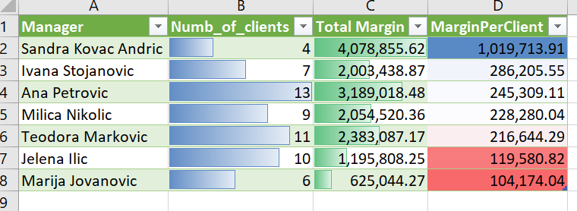

/* =========================================================
10. Koja relacija (origin → destination) ima najveću ukupnu kilometražu?
========================================================= */

-- Koristiti tabelu routes.
-- SUM(distance_km) po origin_id i destination_id.
-- Sortirati opadajuće.

SELECT
r.id,
o.city AS origin_name,
d.city AS destination_name,
SUM(r.distance_km) AS Total_KM
FROM routes r
LEFT JOIN locations o
ON r.origin_id = o.id
LEFT JOIN locations d
ON r.destination_id = d.id
GROUP BY
r.id,
o.city,
d.city
ORDER BY
Total_KM DESC;

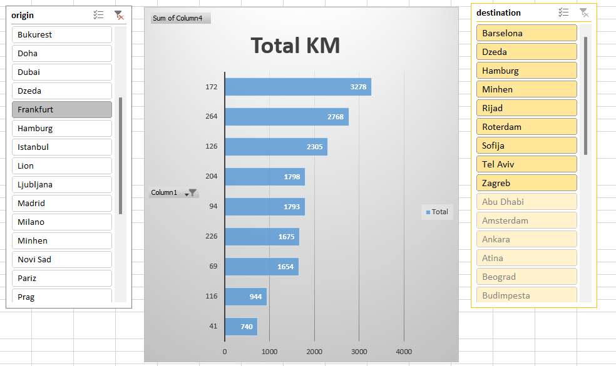

/* =========================================================
11. Ranking klijenata po prihodu unutar industrije
(Window Function)
========================================================= */

-- Izračunati SUM(revenue_eur) po klijentu.
-- Koristiti RANK() ili DENSE_RANK().
-- PARTITION BY industry.
-- ORDER BY ukupni prihod DESC.

WITH client_revenue AS (
SELECT
c.id,
c.client_name,
c.industry,
SUM(s.revenue_eur) AS TotalRevenue
FROM
clients c
LEFT JOIN
shipments s
ON
c.id = s.client_id
GROUP BY
c.id,
c.client_name,
c.industry
)
SELECT
cr.industry,
cr.client_name,
cr.TotalRevenue,
RANK() OVER(PARTITION BY cr.industry ORDER BY cr.TotalRevenue DESC) AS Revenue_Rank
FROM
client_revenue cr
ORDER BY
industry,
Revenue_Rank;
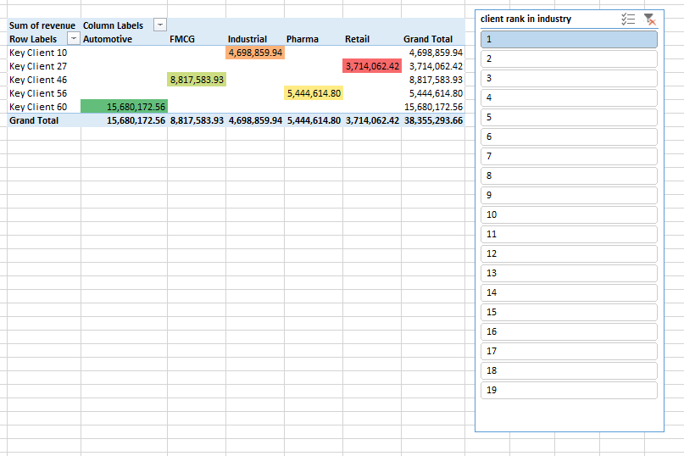

/* =========================================================
12. Mesečni prihod i kumulativni prihod (Running Total)
========================================================= */

-- Grupisati po YEAR(shipment_date) i MONTH(shipment_date).
-- Izračunati mjesečni revenue.
-- Koristiti SUM() OVER (ORDER BY godina, mjesec)
-- za kumulativni prihod.

WITH monthly_revenue AS (
SELECT
YEAR(shipment_date) AS Year,
MONTH(shipment_date) AS Month,
ROUND(SUM(revenue_eur), 2) AS TotalRevenue
FROM shipments
GROUP BY
YEAR(shipment_date),
MONTH(shipment_date)
)

SELECT
Year,
Month,
TotalRevenue,
ROUND(
SUM(TotalRevenue) OVER (ORDER BY Year, Month), 2
) AS CumulativeRevenue
FROM monthly_revenue
ORDER BY
Year,
Month;
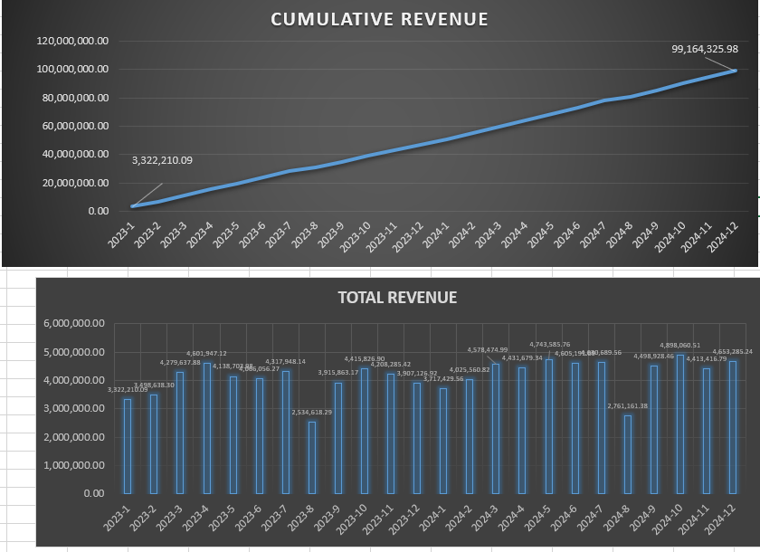

/* =========================================================
13. Year-over-Year (YoY) i Month-over-Month (MoM) rast prihoda
========================================================= */

-- Izračunati godišnji prihod.
-- Koristiti LAG() da dohvatite prihod prethodne godine.
-- Izračunati procentualni rast.

WITH monthly_revenue AS (
SELECT
YEAR(shipment_date) AS Year,
MONTH(shipment_date) AS Month,
SUM(revenue_eur) AS TotalRevenue
FROM shipments
GROUP BY
YEAR(shipment_date),
MONTH(shipment_date)
)

SELECT
Year,
Month,
ROUND(TotalRevenue,2) AS TotalRevenue_TY,
ROUND(LAG(TotalRevenue, 12) OVER (ORDER BY Year, Month),2) AS TotalRevenue_LY,
ROUND(
(TotalRevenue - LAG(TotalRevenue, 12) OVER (ORDER BY Year, Month)) * 1.0
/ LAG(TotalRevenue, 12) OVER (ORDER BY Year, Month),
2
) AS YoY_Revenue_Growth,
ROUND(LAG(TotalRevenue) OVER (ORDER BY Year, Month),2) AS TotalRevenue_LastMonth,
ROUND(
(TotalRevenue - LAG(TotalRevenue) OVER (ORDER BY Year, Month)) * 1.0
/ LAG(TotalRevenue) OVER (ORDER BY Year, Month),
2
) AS MoM_Revenue_Growth
FROM monthly_revenue
ORDER BY
Year,
Month;
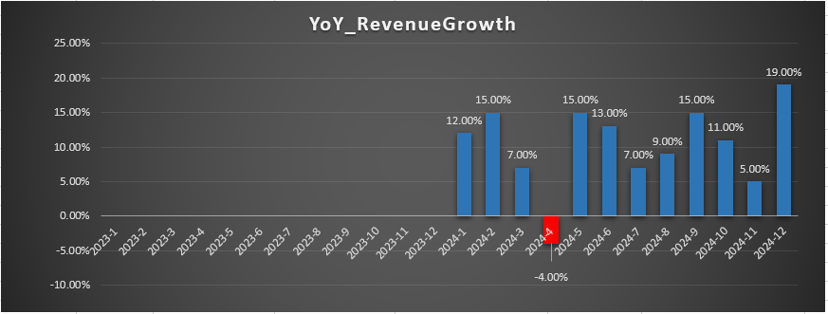
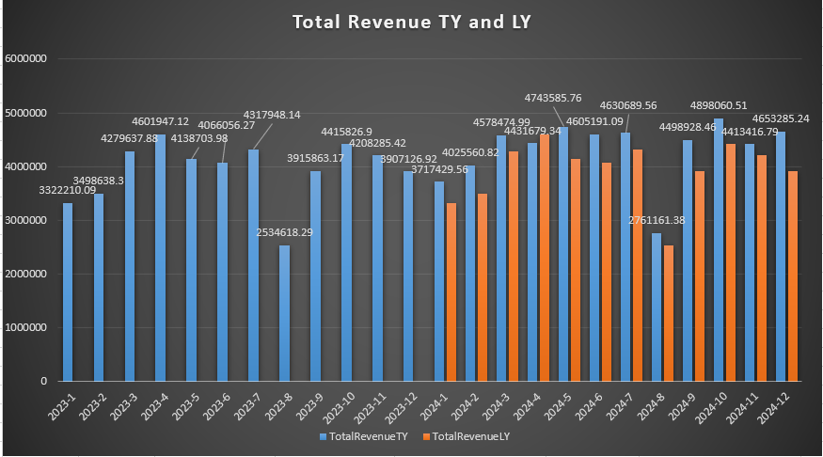
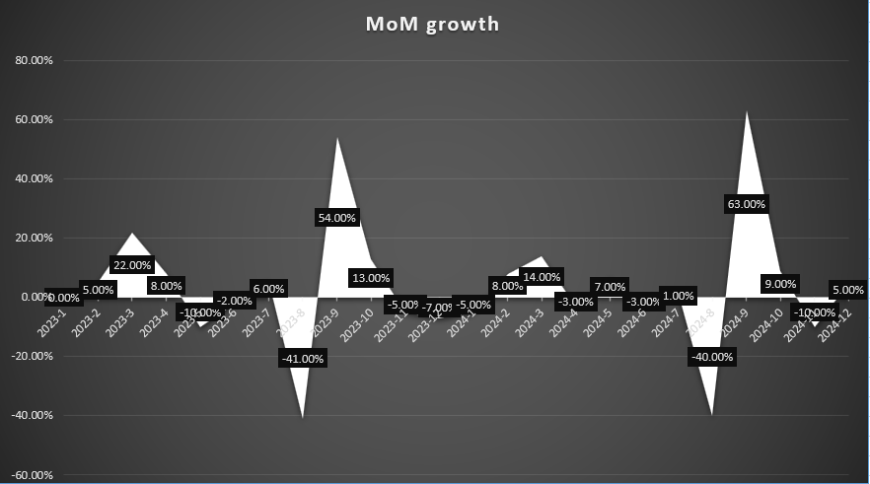

/* =========================================================
14. Profit margin % po klijentu i odstupanje od prosjeka i njihov revenue_share % (učešće svakog klijenta u ukupnom prihodu)
========================================================= */

-- Izračunati margin_pct = margin_eur / revenue_eur.
-- Izračunati prosječni margin_pct koristeći AVG() OVER ().
-- Prikazati razliku između klijenta i globalnog prosjeka.

WITH client_metrics AS (
SELECT
c.client_name,
SUM(s.revenue_eur) AS total_revenue,
SUM(s.margin_eur) AS total_margin
FROM clients c
LEFT JOIN shipments s
ON c.id = s.client_id
GROUP BY c.client_name
),
calculated AS (
SELECT
client_name,
total_revenue,
total_margin,
total_margin / NULLIF(total_revenue, 0) AS margin_pct
FROM client_metrics
)

SELECT
client_name,
margin_pct,
AVG(margin_pct) OVER () AS avg_margin_pct,
margin_pct - AVG(margin_pct) OVER () AS deviation_from_avg,
total_revenue / NULLIF(SUM(total_revenue) OVER (), 0) AS revenue_share
FROM calculated
ORDER BY deviation_from_avg DESC;

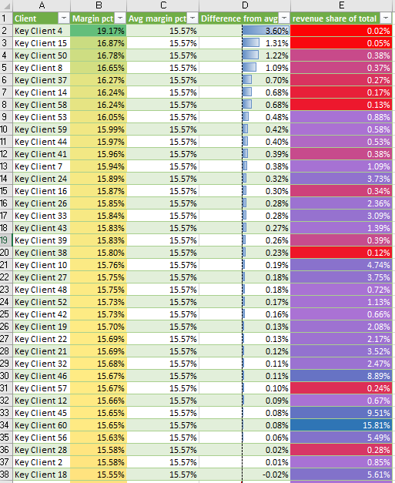
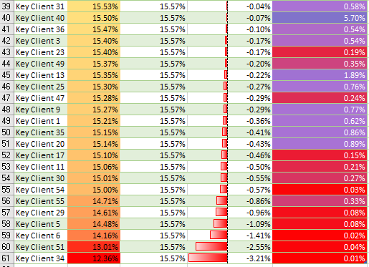

/* =========================================================
15. Najprofitabilnija ruta po regionu (Top 1 po regionu)
========================================================= */

-- Koristiti CTE za agregaciju margin_eur po ruti i regionu.
-- Koristiti ROW_NUMBER().
-- PARTITION BY region.
-- ORDER BY ukupna margina DESC.
-- Filtrirati gdje je row_number = 1.

WITH region_margin_per_route AS (
SELECT
region,
route_id,
SUM(margin_eur) AS TotalMargin
FROM
routes
LEFT JOIN
shipments
ON
routes.id = shipments.route_id
GROUP BY
region,
route_id
),
ranked_routes AS (
SELECT
region,
route_id,
TotalMargin,
ROW_NUMBER() OVER (PARTITION BY region ORDER BY TotalMargin DESC) AS rn
FROM
region_margin_per_route
)
SELECT
region,
route_id,
TotalMargin
FROM ranked_routes
WHERE rn = 1;
